**GIT & GITHUB**

Assignment

1. Create a directory ‘project_dir’ & cd to ‘project_dir’.

2. Initialize git version database. (git init)  
3. Create a new file index.html.

ANS- Solution of above three question is in following screenshot:

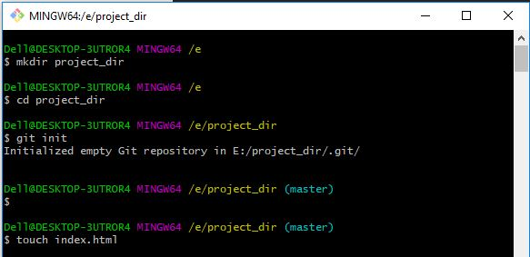  
  
4. Check the git status. You should find index.html as untracked file.  
5. Stage the index.html file.  
6. Commit index.html

7. Make few changes in index.html & create a new file info.txt file.

ANS- Solution of above four question is in following screenshot:

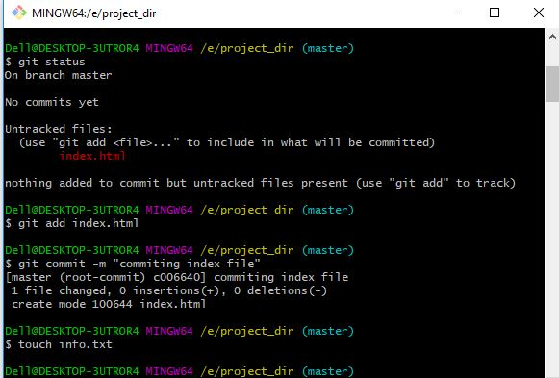  
  
8. Check git status. You should find index.html & info.txt as untracked files.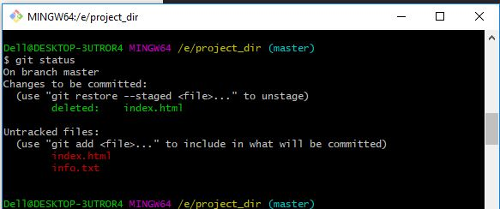

9. Configure GIT to ignore all txt files.

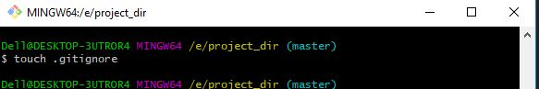

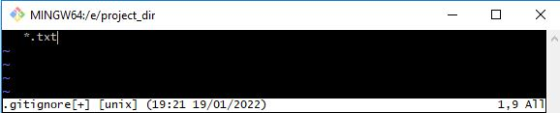

10. Again check the git status. You should find only index.html as untracked file.

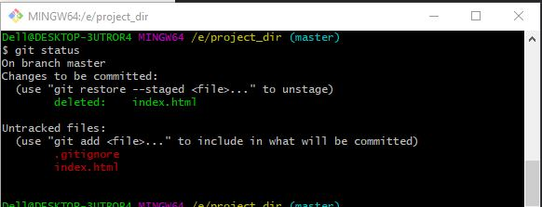

11. State & commit index.html

12. Log all your comments so far.

ANS- Solution of above two question is in following screenshot:

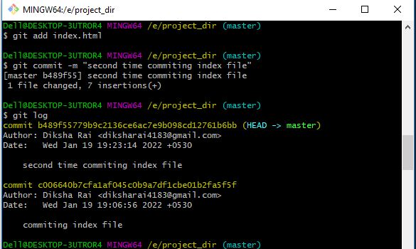

13. Make some changes in index.html.

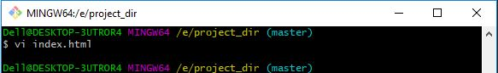

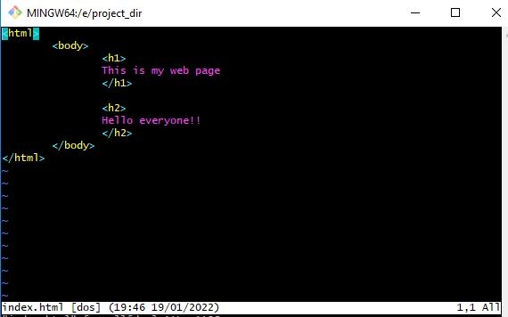

14. Revert the change made in the previous step using git command.

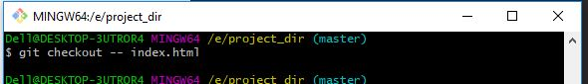

After reverting changes file has changed as below:

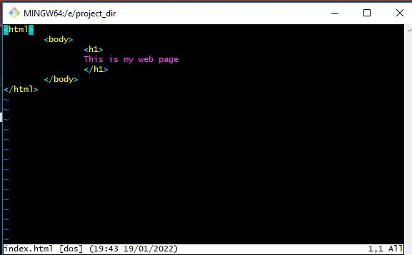

15. Again change index.html.



After changing index file:

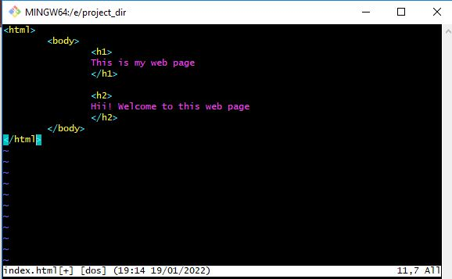

16. Stage index.html  
17. Revert back the last stage.

ANS- Solution of above two question is in following screenshot:

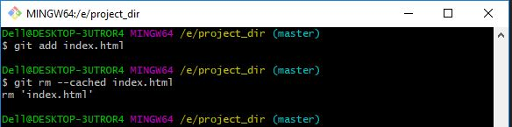  
  
18. Rename ‘add’ command to ‘my-add’.  
19. Using my_add command Stage index.html again & commit the changes.

ANS- Solution of above two question is in following screenshot:

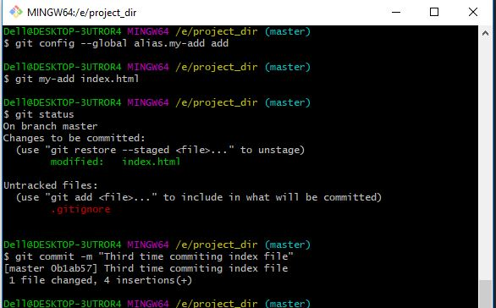

20. Revert the last commit.

Ans: After reverting showing commit log:

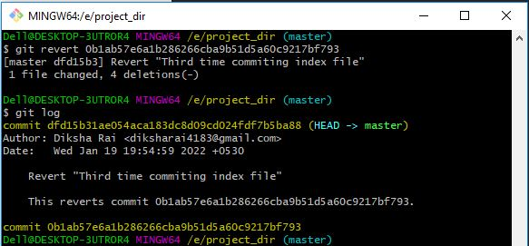

GIT Branching  
Objective: Commit HTML, CSS & JavaScript assignments into GIT.  
SECTION-1 (HTML assignments) - Steps to follow:

21. First take a backup of your assignments & projects. This is required because due to incorrect GIT operation you may lose your files.

- Done

22. Create an empty directory ‘Assignments’ & cd to ‘Assignments’.

23. Create a file README.txt inside ‘Assignments’ & write few lines about the contents of ‘Assignments’ folder.

ANS- Solution of above two question is in following screenshot:

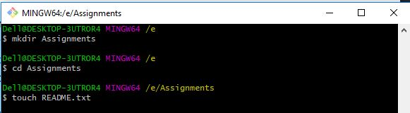

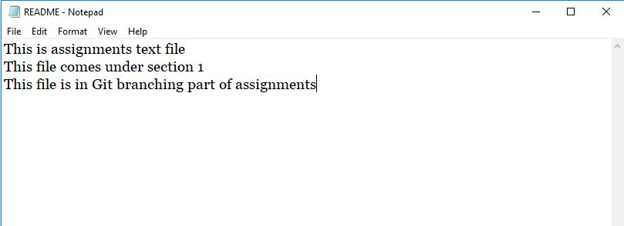

24. Commit README.txt file.

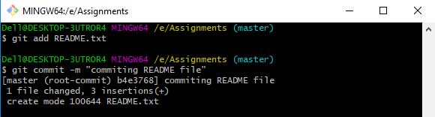

25. Now create a new branch ‘html-assignments’.  
26. Switch to ‘html-assignments’ branch.

ANS- Solution of above two question is in following screenshot:

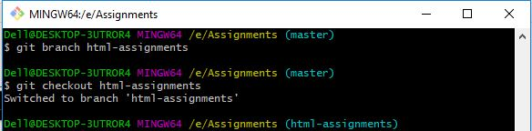

27. Copy all HTML assignments inside ‘Assignments’ folder.  
28. Commit HTML assignments into ‘html-assignments’ branch.

29. Make minor changes into few files belonging to ‘html-assignments’ branch.

ANS- Solution of above three question is in following screenshot:

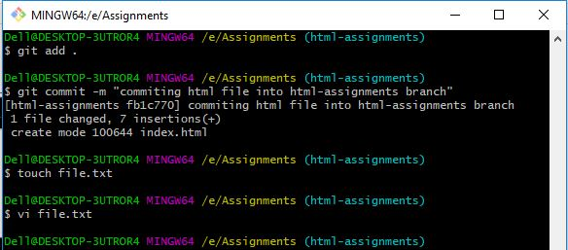

30. Commit those changed files.  
31. Switch to master branch.  
32. Make minor changes into README.txt file & commit those changes into master.  
33. Again switch to ‘html-assignments’ branch.  
34. Make minor changes into few files belonging to ‘html-assignments’ branch.

ANS- Solution of above five question is in following screenshot:

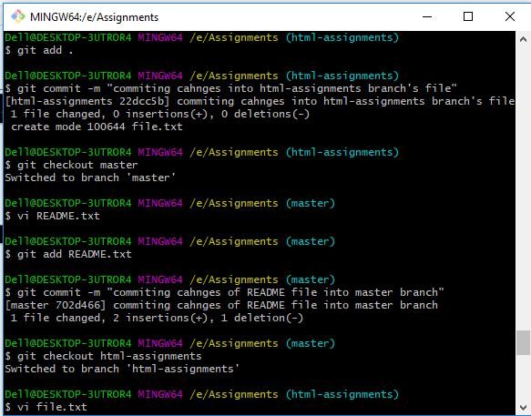

35. Commit those changes.  
36. Switch to master.  
37. Merge ‘html-assignments’ branch into master. Confirm all html assignments are shown in master.

38. Finally delete the ‘html-assignments’ branch.

ANS- Solution of above four question is in following screenshot:

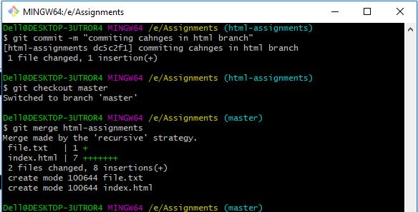  
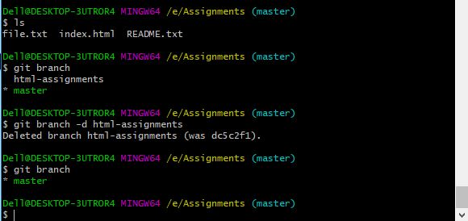

SECTION-2 - (CSS assignments) Steps to follow:  
1. Create a new branch ‘css-assignments’.  
2. Switch to ‘css-assignments’ branch.

ANS- Solution of above two question is in following screenshot:

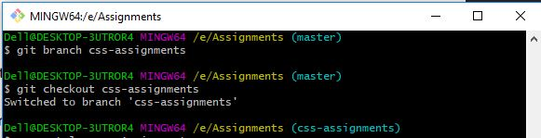

3. Copy all CSS assignments inside ‘Assignments’ folder.  
4. Commit CSS assignments into ‘css-assignments’ branch.

ANS- Solution of above two question is in following screenshot:

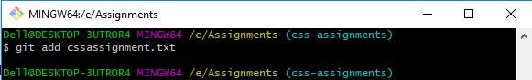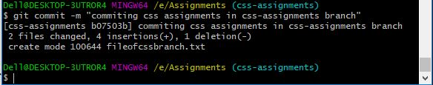

5. Make minor changes into README.txt file on line 1 belonging to ‘css-assignments’ branch.  
6. Commit those changed files.  
7. Switch to master branch.

ANS- Solution of above three question is in following screenshot:

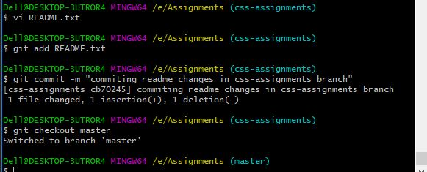

8. Make minor changes into README.txt file on line 3 & commit those changes into master.

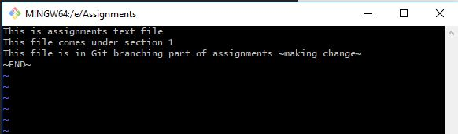

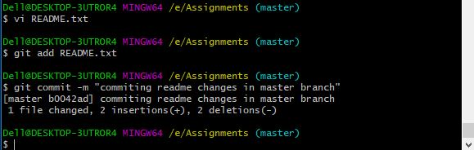

9. Again switch to ‘css-assignments’ branch.  
10. Make minor changes into few files belonging to ‘css-assignments’ branch.

ANS- Solution of above two question is in following screenshot:

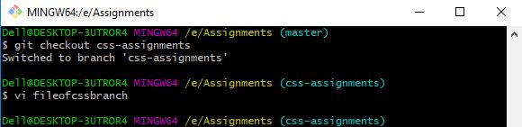

11. Commit those changes.  
12. Switch to master.

ANS- Solution of above two question is in following screenshot:

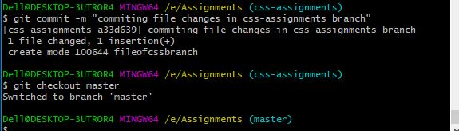

13. Merge ‘css-assignments’ branch into master. Confirm all css assignments are shown in master.

14. Finally delete the ‘css-assignments’ branch.

ANS- Solution of above two question is in following screenshot:

After deleting branch showing present branches as well:

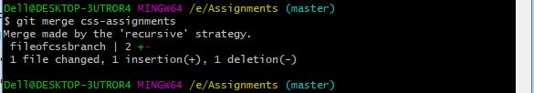

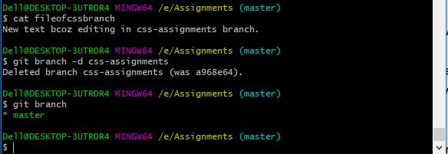

SECTION-3 - (JavaScript assignments) Steps to follow:

1. Create a new branch ‘js-assignments’.

ANS-

Dell@DESKTOP-3UTROR4 MINGW64 /e/Assignments (master)

$ git branch js-assignments

2. Switch to ‘js-assignments’ branch.

ANS-

Dell@DESKTOP-3UTROR4 MINGW64 /e/Assignments (master)

$ git checkout js-assignments

Switched to branch 'js-assignments'

3. Copy all JavaScript assignments inside ‘Assignments’ folder.

ANS- copied two files:

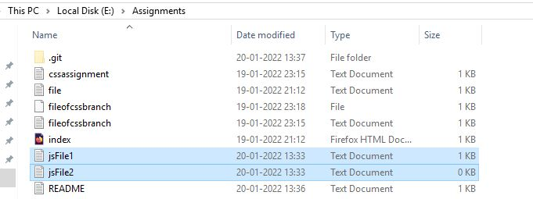

4. Commit JavaScript assignments into ‘js-assignments’ branch.

ANS-

Dell@DESKTOP-3UTROR4 MINGW64 /e/Assignments (js-assignments)

$ git add jsFile1.txt

Dell@DESKTOP-3UTROR4 MINGW64 /e/Assignments (js-assignments)

$ git add jsFile2.txt

Dell@DESKTOP-3UTROR4 MINGW64 /e/Assignments (js-assignments)

$ git commit -m "commiting java script assignments into js-assignments"

[js-assignments 6fcc5f6] commiting java script assignments into js-assignments

2 files changed, 0 insertions(+), 0 deletions(-)

create mode 100644 jsFile1.txt

create mode 100644 jsFile2.txt

5. Make minor changes into README.txt file on line 1 belonging to ‘js-assignments’ branch.

ANS-

Dell@DESKTOP-3UTROR4 MINGW64 /e/Assignments (js-assignments)

$ vi README.txt

Made changes on line 1 in js-assignments branch:

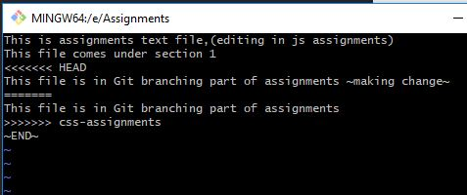

6. Commit those changed files.

ANS-

Dell@DESKTOP-3UTROR4 MINGW64 /e/Assignments (js-assignments)

$ git add README.txt

Dell@DESKTOP-3UTROR4 MINGW64 /e/Assignments (js-assignments)

$ git commit -m "commiting changes of readme file into js-assignments"

[js-assignments 10d4895] commiting changes of readme file into js-assignments

1 file changed, 1 insertion(+), 3 deletions(-)

7. Switch to master branch.

ANS-

Dell@DESKTOP-3UTROR4 MINGW64 /e/Assignments (js-assignments)

$ git checkout master

Switched to branch 'master'

8. Make minor changes into README.txt file on line 1 & commit those changes into master.

ANS-

Dell@DESKTOP-3UTROR4 MINGW64 /e/Assignments (master)

$ vi README.txt

Made changes on line 1 in master branch:

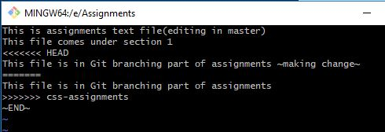

Dell@DESKTOP-3UTROR4 MINGW64 /e/Assignments (master)

$ git add README.txt

Dell@DESKTOP-3UTROR4 MINGW64 /e/Assignments (master)

$ git commit -m "commiting changes of readme file into master branch"

[master 8cea66f] commiting changes of readme file into master branch

1 file changed, 1 insertion(+), 3 deletions(-)

9. Again switch to ‘js-assignments’ branch.

ANS-

Dell@DESKTOP-3UTROR4 MINGW64 /e/Assignments (master)

$ git checkout js-assignments

Switched to branch 'js-assignments'

10. Make minor changes into few files belonging to ‘js-assignments’ branch.

ANS-

Dell@DESKTOP-3UTROR4 MINGW64 /e/Assignments (js-assignments)

$ vi jsFile1.txt

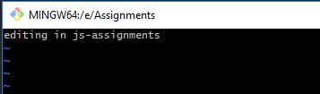

11. Commit those changes.

ANS-

Dell@DESKTOP-3UTROR4 MINGW64 /e/Assignments (js-assignments)

$ git add .

Dell@DESKTOP-3UTROR4 MINGW64 /e/Assignments (js-assignments)

$ git commit -m "commiting java script assignments file into js-assignments"

[js-assignments 7c7826d] commiting java script assignments file into js-assignments

1 file changed, 1 insertion(+)

12. Switch to master.

ANS-

Dell@DESKTOP-3UTROR4 MINGW64 /e/Assignments (js-assignments)

$ git checkout master

Switched to branch 'master'

13. Merge ‘js-assignments’ branch into master. Confirm all JavaScript assignments are shown in master.

ANS-

Dell@DESKTOP-3UTROR4 MINGW64 /e/Assignments (master)

$ git merge js-assignments

Auto-merging README.txt

Merge made by the 'recursive' strategy.

README.txt | 2 +-

1 file changed, 1 insertion(+), 1 deletion(-)

Dell@DESKTOP-3UTROR4 MINGW64 /e/Assignments (master)

$ cat jsFile1.txt

editing in js-assignments.

Dell@DESKTOP-3UTROR4 MINGW64 /e/Assignments (master)

$ cat README.txt

<<<<<<< HEAD

This is assignments text file(editing in master)

=======

This is assignments text file,(editing in js assignments)

>>>>>>> js-assignments

This file comes under section 1

<<<<<<< HEAD

This file is in Git branching part of assignment ~making change~

=======

This file is in Git branching part of assignments

>>>>>>> css-assignments

~END~

14. Finally delete the ‘js-assignments’ branch.

ANS-

Dell@DESKTOP-3UTROR4 MINGW64 /e/Assignments (master)

$ git branch -d js-assignments

Deleted branch js-assignments (was 7b454e4).

Dell@DESKTOP-3UTROR4 MINGW64 /e/Assignments (master)

$ git branch

* master

GIT Remoting  
Objective: Pushing source code into GITHUB & collaborate team members.

SECTION-1 (Pushing assignments to remote repository) - Steps to follow:  
39. Create a github account if you do not have already.

ANS- I do have account on Github already.  
40. Login on into github account.  
41. Create new public repository ‘freshersbatch-oct16’.

ANS- Solution of above two question is in following screenshot:

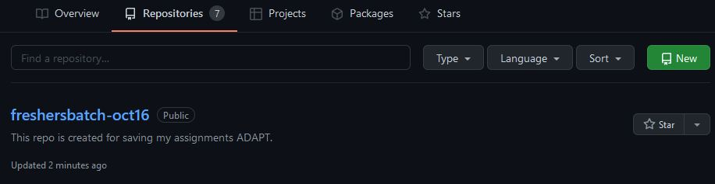

42. Commit & push any sample file to this repository under ‘Assignments’ directory.

Dell@DESKTOP-3UTROR4 MINGW64 /e/Assignments (master)

$ git commit -m "Final commit before first push"

[master cdd11b9] Final commit before first push

2 files changed, 2 insertions(+)

Dell@DESKTOP-3UTROR4 MINGW64 /e/Assignments (master)

$ git remote add origin https://github.com/Diksha-Rai/freshersbatch-oct16.git

Dell@DESKTOP-3UTROR4 MINGW64 /e/Assignments (master)

$ git remote -v

origin https://github.com/Diksha-Rai/freshersbatch-oct16.git (fetch)

origin https://github.com/Diksha-Rai/freshersbatch-oct16.git (push)

Dell@DESKTOP-3UTROR4 MINGW64 /e/Assignments (master)

$ git push -u origin master

Logon failed, use ctrl+c to cancel basic credential prompt.

Enumerating objects: 65, done.

Counting objects: 100% (65/65), done.

Delta compression using up to 4 threads

Compressing objects: 100% (56/56), done.

Writing objects: 100% (65/65), 6.45 KiB | 157.00 KiB/s, done.

Total 65 (delta 24), reused 0 (delta 0), pack-reused 0

remote: Resolving deltas: 100% (24/24), done.

To https://github.com/Diksha-Rai/freshersbatch-oct16.git

* [new branch] master -> master

Branch 'master' set up to track remote branch 'master' from 'origin'.

After pushing files to remote repository(fresherbatch-oct16):

